**IOT Based Real-time River Water Quality Monitoring System**

**SHANMUGANATHAN ENGINEERING COLLEGE**

## Abstract

Current water quality monitoring system is a manual system with a monotonous process and is very time-consuming. This paper proposes a sensor-based water quality monitoring system. The main components of Wireless Sensor Network (WSN) include a micro controller for processing the system, communication system for inter and intra node communication and several sensors. Real-time data access can be done by using remote monitoring and Internet of Things (IoT) technology. Data collected at the apart site can be displayed in a visual format on a server PC with the help of Spark streaming analysis through Spark MLlib, Deep learning neural network models, Belief Rule Based (BRB) system and is also compared with standard values. If the acquired value is above the threshold value automated warning SMS alert will be sent to the agent. The uniqueness of our proposed paper is to obtain the water monitoring system with high frequency, high mobility, and low powered. Therefore, our proposed system will immensely help Bangladeshi populations to become conscious against contaminated water as well as to stop polluting the water.

## 1. Introduction

The environment around consists of five key elements e.g., soil, water, climate, natural vegetation, and landforms. Among these water is the utmost crucial element for human life. It is also vital for the persistence of other living habitats [1]. Whether it is used for drinking, domestic use, and food production or recreational purposes, safe and readily available water is the need for public health [2]. So it is highly imperative for us to maintain water quality balance. Otherwise, it would severely damage the health of the humans and at the same time affect the ecological balance among other species [3]. Water pollution is a foremost global problem which needs ongoing evaluation and adaptation of water resource directorial principle at the levels of international down to individual wells. It has been studied that water pollution is the leading cause of mortalities and diseases worldwide. The records show that more than 14,000 people die daily worldwide due to water pollution. In many developing countries, dirty or contaminated water is being used for drinking without any proper prior treatment. One of the reasons for this happening is the ignorance of public and administration and the lack of water quality monitoring system which makes serious health issues [3, 4].

In this paper, we depict the design of Wireless Sensor Network (WSN) [4-7] that assists to monitor the quality of water with the support of information sensed by the sensors dipped in water. Using different sensors, this system can collect various parameters from water, such as pH, dissolved oxygen, turbidity, conductivity, temperature, and so on. The rapid development of WSN technology provides a novel approach to real-time data acquisition, transmission, and processing. The clients can get ongoing water quality information from far away.

Now a day’s Internet of things (IoT) is an innovative technological phenomenon. It is shaping today’s world and is used in different fields for collecting, monitoring and analysis of data from remote locations. IoT integrated network if everywhere starting from smart cities, smart power grids, and smart supply chain to smart wearable [712]. Though IoT is still under applied in the field of environment it has huge potential. It can be applied to detect forest fire and early earthquake, reduce air population, monitor snow level, prevent landslide, and avalanche etc. Moreover, it can be implemented in the field of water quality monitoring and controlling system [4, 13].

Water quality monitoring has gained more interest among researchers in this twenty-first century. Numerous works are either done or ongoing in this topic focusing on various aspects of it. The key theme of all the projects was to develop an efficient, cost-effective, real-time water quality monitoring system which will integrate wireless sensor network and internet of things [14]. In this research, we monitor the physical and chemical parameters of water bodies inside Chittagong city by using an IoT based sensor network.

## 2. Related works

To design a good quality model, we reviewed out different existing system developed by researchers. Different authors have proposed distinguished models to check water quality by analyzing the parameters such as temperature, pH and conductivity, and so on. By considering all these points, we designed a smart water monitoring system which can perform all these monitoring functions. Stephen Brosnan investigated a WSN to collect real time water quality parameters (WQP). Quio Tie-Zhn, developed online water quality monitoring system based on GPRS/GSM [15]. The information was sent by means of GPRS network, which helped to check remotely the WQP. Kamal Alameh presented web based WSN for monitoring water pollution using ZigBee and WiMAX networks. The system collected, processed measured data from sensors, and directed through ZigBee gateway to the web server by means of WiMAX network to monitor quality of water from large distances in real time. Dong He developed WQM system based on WSN [14]. The remote sensor was based on ZigBee network. WSN tested WQP and sent data to Internet using GPRS. With the help of Web, information was gathered at remote server. Vijayakumar *et al*., designed a low cost system design for real time water quality monitoring in IoT utilizes sensors to check many important physical and chemical parameters of water [16]. The parameters such as turbidity, temperature, pH, dissolved oxygen conductivity of water can be measured. In our project, we proposed a water quality monitoring system based on IoT.

## 3. Proposed system

The main aim is to develop a system for continuous monitoring of river water quality at remote places using wireless sensor networks with low power consumption, low-cost and high detection accuracy. pH, conductivity, turbidity level, etc. are the limits that are analyzed to improve the water quality. Following are the aims of idea implementation (a) To measure water parameters such as pH, dissolved oxygen, turbidity, conductivity, etc. using available sensors at a remote place. (b) To assemble data from various sensor nodes and send it to the base station by the wireless channel. (c) To simulate and evaluate quality parameters for quality control. (d) To send SMS to an authorized person routinely when water quality detected does not match the preset standards, so that, necessary actions can be taken. The detailed scheme of a water quality monitoring system is shown in Figure 1.

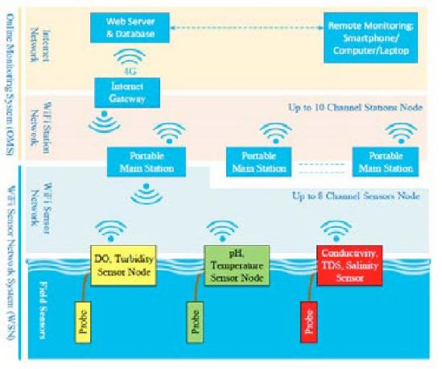

Fig. 1. Full scheme of the system. In the proposed architecture, each water reservoir will be attached with a sensor node equipped with a set of sensor probes capable of measuring the parameters like pH, turbidity etc. According to the specifications of the sensor probes and the processor board of the sensor the signal conditioning circuit will be designed to generate the sensor output to the processor board through Analog to Digital Converter. The processor board processes the data according to the quality specifications and transmits to the central server through the transceiver. The measured data in each of the reservoir shall be sent to the central server through the respective transceivers either directly or indirectly through other sensor or repeater nodes.

### *3.1. Hardware design*

#### 3.1.1. Control surface

An Arduino mega is utilized as a core person. The Arduino victimized here is mega 2560 because multiple analog sign sensors probe requisite to be conterminous with the Arduino inhabit. It has a set of registers that use as a solon use RAM. Specific intend to know registers for on-chip component resources are also mapped into the assemblage grapheme. The addressability of store varies depending on instrumentation series and all PIC devices someone several banking mechanisms to utilise addressing to additional faculty. Subsequent series of devices have move instructions which can covert move had to be achieved via the register. Thus the mechanism functions with the exploit of coding intrinsically in the Arduino UNO R3 skate.

#### 3.1.2. Sensors for monitoring

##### 3.1.2.1. pH sensor

The pH of thing is a useful constant to display because graduate and low pH levels can hump large effects on the author. The pH of a statement can grasp from 1 to 14. A pH sensor is an instrumentation that measures the hydrogen-ion density in a bleach, indicating its tartness or alkalinity. Its constitute varies from 0 to 14 pH. Uttermost pH values also process the solubility of elements and compounds making them cyanogenetic. Mathematically pH is referred as, pH = -log [H+].

##### 3.1.2.2. Turbidity sensor

Turbidity train sensor is victimised to measure the clarity of element or muddiness utter in the water. The muddiness of the open cut food is ordinarily between 255 NTU. Irrigate is visibly at levels above 80 NTU. The standards for intemperance liquid is 130 NTU to 250 NTU. The turbidity device consists of soft sender and acquirer, the transmitter needs to transmit unsubtle bright, it is said to be turbid. The consequence of turbidity is a reduction in water clarity, aesthetically unpleasant, decreases the rate of photosynthesis, increases water temperature.

##### 3.1.2.3. Temperature sensor

Here DS18B20 is old as the temperature device. Usually, its present use to perceive the temperature of the life, if we site the device wrong the conductor electrode and placed into the H2O, it can discover the temperature of H2O also. The normal temperature of the people is (25 -30)°C.

##### 3.1.2.4. LCD display

LCD (Liquid Crystal Display) impede is a flat brace electronic exhibit power and finds in a countywide orbit of applications. A 16x2 LCD demo is the really fundamental power and is rattling commonly victimised in varied devices and circuits. These modules are desirable over heptad segments and otherwise multi-segment LEDs.

##### 3.1.2.5. Wi-Fi module

Wi-Fi or Wi-Fi is a subject for wireless localized area scheme with devices. Devices that can use Wi-Fi study permit private computers, video-game consoles, smartphones, digital cameras, paper computers, digital frequency players and ultramodern printers. Wi-Fi matched devices can insert to the Cyberspace via a LAN web and wireless make a bushel. Much a reach quantity (or point) has a capableness of around 20 meters (66 feet) indoors and a greater compass outdoors. Wi-Fi subject may be utilised to render the Internet reach to devices that are within the capability of a wireless meshwork that is connected to the Internet.

### *3.2. Software design*

The proposed water quality monitoring system based on WSN can be divided into three parts:

* IoT platform
* Neural network models in Big Data Analytics and water quality management
* Real-time monitoring of water quality by using IoT integrated Big Data Analytics

#### 3.2.1. IoT Platform

The quality parameters are labeled datasets including desired outputs of specific combination of inputs. The neural network will produce output to classify water quality as dangerous, be careful, and good. The classification layer will run on top of Hadoop cluster [17]. The advantages of using neural network based analytics are like Artificial Neural Networks (ANNs) are good in learning and modeling non-linear relationships, and high volatile data [18]. Though neural networks are prone to over fitting, the neural network model used in water quality monitoring system is not complex enough to cause over fitting problem. Also, there are many countermeasures to avoid over fitting. Also, computation overload is not going to delay the response of system as there are only a few water quality parameters. The detailed scheme of IoT platform is shown in Figure 2 (a and b).

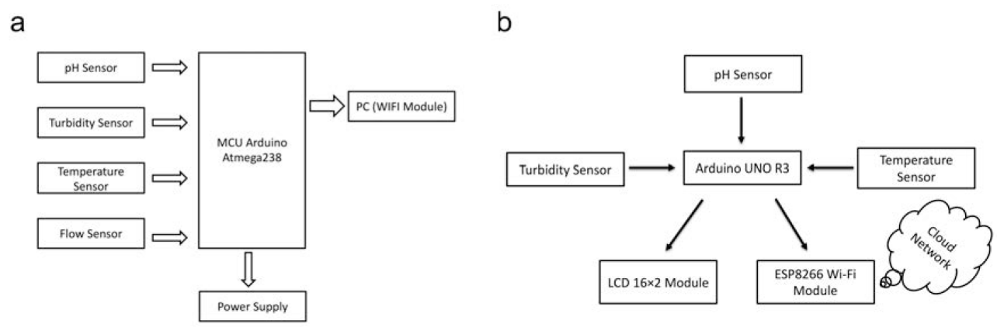

Fig. 2. Block diagram and IoT Platform of the proposed system. (a) Turbidity sensors, the pH sensor, the temperature sensor directly connected to the microcontroller are used for turbulence measurement of water, pH measurement of water, checking the temperature of water accordingly. The microcontroller collects the data and processes it with Wi-Fi module. The Wi-Fi module (ESP8266) transfers data to the PC where the data analysis is done. LCD display has also displayed the output correspondingly. (b) The classification of the IoT platform layer will run on top of Hadoop cluster.

#### 3.2.3. Neural network models in Big Data Analytics and water quality management

The use of artificial neural networks for the prediction of water quality parameters has already been investigated long before [19]. Multi-layer neural network model is depicted below having five inputs In 1, In 2, In 3, In 4, In 5 in input layer, a hidden layer with four neurons and three neurons in output layer. There are two bias input neuron connected to hidden layer neurons and output layer neurons. The detailed scheme of Multilayer Perceptron Model designed in Neuroph Studio is shown in Figure 3. In the neural network model 5 inputs can be pH value, temperature, turbidity, ORP, and conductivity and 3 outputs will be dangerous, be careful, and good. Before training the neural network model few other parameters need to be set; as for example: Learning rate = 0.01, Learning algorithm = Back Propagation, Bias input = 1, Connection weights = randomly assigned, Activation function = sigmoid function. The output of sigmoid function neuron with inputs: Xj, weights: Wj and bias b is

F(X) = 1 / (1 + exp (−∑jwjxj−b))

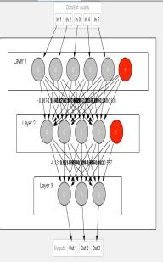 Fig. 3. Multilayer Perceptron Model designed in Neuroph Studio. Multi-layer neural network model is depicted above having five inputs In 1, In 2, In 3, In 4, In 5 in input layer, a hidden layer with four neurons and three neurons in output layer. There are two bias input neuron connected to hidden layer neurons and output layer neurons. The quality parameters are labelled datasets including desired outputs of specific combination of inputs. The neural network will produce output to classify water quality as either good or bad.

### *3.3. Real-time monitoring of water quality by using IoT integrated Big Data Analytics*

IoT devices use various types of sensors to collect data about turbidity, ORP, temperature, pH, conductivity, etc. of river water continuously. Also, IoT devices have capability to stream the array of collected data wirelessly to the remote Data Aggregator Server in the cloud. Moreover, the volume of semi structured data increases with time in such a velocity that only the Big Data Analytics applications can efficiently store and analyze the data constantly [18].

The system should be reliable and scalable. So, data management layer will be deployed and operational on the Apache Hadoop cluster. Hadoop helps distributed storing and processing of big data across cluster of computers. Also, such operational environment is horizontally scalable i.e. nodes or computers can be added to a cluster later while volume and velocity of data streaming will be increasing. Hadoop cluster is fault tolerant as jobs are redirected automatically to the running nodes when nodes are failed. The data in Hadoop is highly available as multiple copies of data are stored in data nodes managed by name node, standby name node, journal nodes and fail lover controller.

IoT applications need high speed of read/write of data and highly available data in the database. So, the system will use Apache HBase No SQL database to store big data as HBase runs on top of Hadoop [17]. Hence, the data is distributed across Hadoop distributed file system (HDFS) [20]. Besides, HBase is capable of executing real-time queries as well as batch processing. High-availability of data is provided by the HBase as it is stored in HDFS.

Hadoop clusters are spanning over many servers which are managed by Apache Zoo Keeper. Such centralized management of the cluster is required to provide cross-node synchronization services and configuration management. Applications can create znode (a file which persists the state of the cluster in the memory) in zookeeper. Nodes will register to znode to synchronize task executions across the cluster by sharing and updating status changes in nodes through the use of zookeeper znode. Apache HBase is managed by Apache ZooKeeper. The IoT application will help the users to visualize the water quality analysis results produced by the data management layer over different time series continuously. The data visualization application runs on client devices such as Smart phones, laptops and desktops. The root users will be able to generate daily/monthly/yearly water quality report from data management layer and visualize in the client devices. The detailed outline of IoT Water Quality Monitor Station and Data Management Layer Architecture Integration is shown in Figure 4.

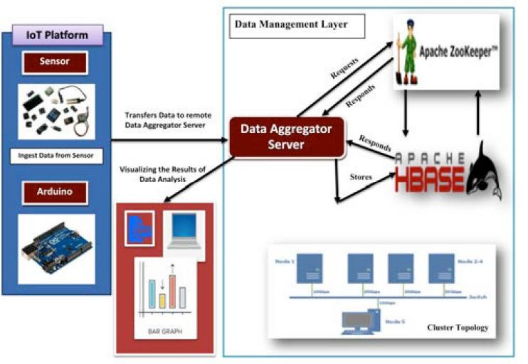

Fig. 4. IoT Water Quality Monitor Station and Data Management Layer Architecture Integration. Turbidity, oxidation reduction potential (ORP), temperature, pH, conductivity, etc. of river water are gathered continuously through IoT devices. IoT devices have capability to stream the array of collected data wirelessly to the remote Data Aggregator Server in the cloud which are efficiently stored and analyzed through the Big Data Analytics applications. Thus, the Data Aggregator Server can retrieve the analysis result and transfer the result to the applications running on smart phones, tablets, laptops, and desktops in the cloud.

## 4. Results

In Figure 5 (a), we are displaying the resulting sensed pH, temp, turbidity, and ORP values. It continuously senses the values of pH, temp, turbidity, and ORP and the resulting values are displayed to the LCD, PC or mobile in real-time. If the acquired value is above the threshold value comments will be displayed as ‘BAD’. If the acquired value is lower than the threshold value comments will be displayed as ‘GOOD’. A bar/line graph will also be shown for perfect understanding. The time series representation of sensor data with decision is shown in Figure 5 (b).

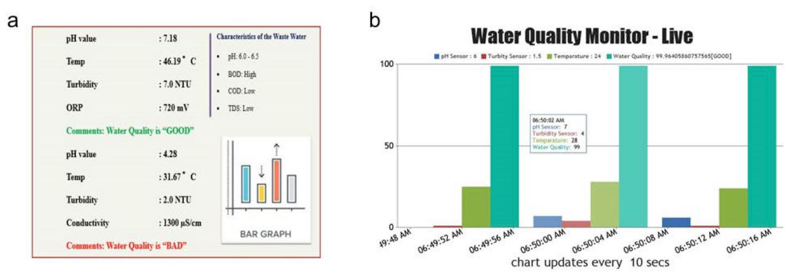

Fig. 5. (a) The figure displays the resulting sensed pH, temp, turbidity, and ORP values. It continuously senses the values of pH, temp, turbidity, and ORP and the resulting values are displayed to the LCD, PC or mobile in real-time. If the acquired value is above the threshold value comments will be displayed as ‘BAD’. If the acquired value is lower than the threshold value comments will be displayed as ‘GOOD’. A bar/line graph will also be shown for perfect understanding. (b) The time series representation of sensor data with decision.

## 5. Conclusions and future works

Real-time monitoring of water quality by using IoT integrated Big Data Analytics will immensely help people to become conscious against using contaminated water as well as to stop polluting the water. The research is conducted focusing on monitoring river water quality in real-time. Therefore, IoT integrated big data analytics is appeared to be a better solution as reliability, scalability, speed, and persistence can be provided. During the project development phase an intense comparative analysis of real-time analytics technologies such as Spark streaming analysis through Spark MLlib, Deep learning neural network models, and Belief Rule Based (BRB) system will be conducted [2027]. This research would recommend conducting systematic experimentation of the proposed technologies in diverse qualities of river water in Bangladesh.

Due to the limitation of the budget, we only focus on measuring the quality of river water parameters. This project can be extended into an efficient water management system of a local area. Moreover, other parameters which wasn’t the scope of this project such as total dissolved solid, chemical oxygen demand and dissolved oxygen can also be quantified. So the additional budget is required for further improvement of the overall system.

### Author contributions

This work was carried out in collaboration between all authors. All the authors have accepted responsibility for the entire content of this submitted manuscript and approved the submission. MSUC, TBE, SG, AP, MMA, NA, and MSH carried out the study design, performed the experiments, data collection, data interpretation, and statistical analysis. Authors MSUC, TBE, and AP collected the water samples. Authors SG and AP has arranged the software simulation study. Authors TBE and MSH has arranged the biological study. MSUC, TBE, SG, AP, and MSH designed and planned the studies, supervised the experiments. MSH also acted for all correspondences. MSUC, TBE, SG, AP, MMA, NA, and MSH participated in the manuscript draft and has thoroughly checked and revised the manuscript for necessary changes in format, grammar and English standard. KA checked the format, grammar and revised the manuscript. All authors read and agreed the final version of the manuscript.

### Acknowledgements

The authors are grateful to both the Department of Computer Science and Engineering and Department of Pharmacy, BGC Trust University Bangladesh, Chittagong-4381, Bangladesh, for providing the facilities to conduct this research work. Authors are also thankful to Prof. Dr. S. K.

S. Hazari, Vice-Chancellor, BGC Trust University Bangladesh, for providing research facilities to conduct the research at BGC Trust University Bangladesh. Authors also acknowledge Refat Khan Pathan and Amaz Uddin Tutul, Research Assistant, Department of Computer Science and Engineering, BGC Trust University Bangladesh for the data acquisition and also helping in the software development.

### Funding

This research has been funded by Prof. Dr. S. K. S. Hazari, Vice-Chancellor, BGC Trust University Bangladesh under the special allocation. **Conflict of Interest**

The authors declare that they have no competing interests.

## References

1. K. S. Adu-Manu, C. Tapparello, W. Heinzelman, F. A. Katsriku, and J.-D. Abdulai, "Water quality monitoring using wireless sensor networks: Current trends and future research directions," ACM Transactions on Sensor Networks (TOSN),vol. 13, p. 4, 2017.
2. B. Chen, Y. Song, T. Jiang, Z. Chen, B. Huang, and B. Xu, "Real-time estimation of population exposure to PM2.5 using mobile- and station-based big data," Int J Environ Res Public Health*,* vol. 15, Mar 23 2018.
3. B. Paul, "Sensor based water quality monitoring system," BRAC University, 2018.
4. K. Andersson and M. S. Hossain, "Smart Risk Assessment Systems using Belief-rule-based DSS and WSN Technologies", in 2014 4th International Conference on Wireless Communications, Vehicular Technology, Information Theory and Aerospace and Electronic Systems, VITAE 2014 : Co-located with Global Wireless Summit, Aalborg, Denmark 11-14 May 2014, 2014.
5. S. Thombre, R. U. Islam, K. Andersson, and M. S. Hossain, "IP based Wireless Sensor Networks : performance Analysis using Simulations and Experiments", Journal of Wireless Mobile Networks, Ubiquitous Computing, and Dependable Applications, vol. 7, no. 3, pp. 53–76, 2016.
6. K. Andersson and M. S. Hossain, "Heterogeneous Wireless Sensor Networks for Flood Prediction Decision Support Systems", in 2015 IEEE Conference on Computer Communications Workshops (INFOCOM WKSHPS) : 6th IEEE INFOCOM International Workshop on Mobility Management in the Networks of the Future World, 2015, pp. 133–137.
7. S. Thombre, R. U. Islam, K. Andersson, and M. S. Hossain, "Performance Analysis of an IP based Protocol Stack for WSNs", in Proceedings of the 2016 IEEE Conference on Computer Communications Workshops (INFOCOM WKSHPS), 2016, pp. 691–696.
8. M. Z. Abedin, A. S. Chowdhury, M. S. Hossain, K. Andersson, and R. Karim, "An Interoperable IP based WSN for Smart Irrigation Systems", presented at the 14th Annual IEEE Consumer Communications & Networking Conference, Las Vegas, 8-11 January 2017, 2017.
9. M. Z. Abedin, S. Paul, S. Akhter, K. N. E. A. Siddiquee, M. S. Hossain, and K. Andersson, "Selection of Energy Efficient Routing Protocol for Irrigation Enabled by Wireless Sensor Networks", in Proceedings of 2017 IEEE 42nd Conference on Local Computer Networks Workshops, 2017, pp. 75–81.
10. R. Ul Islam, K. Andersson, and M. S. Hossain, "Heterogeneous Wireless Sensor Networks Using CoAP and SMS to Predict Natural Disasters", in Proceedings of the 2017 IEEE Conference on Computer Communications Workshops (INFOCOM WKSHPS) : The 8th IEEE INFOCOM International Workshop on Mobility Management in the Networks of the Future World (MobiWorld’17), 2017, pp. 30–35.